Polling certain ISO standard OIDs doesn't work in AOS-CX

**Labels: ArubaOS-CX Switches**

**Requirement:**

It might have occurred to you that polling certain OIDs didn't work.

OIDs we are talking about is incorporated in industry standard MIBs.

1.3.6.1.2.1....

1(iso).3(org).6(dod).1(internet).2(mgmt).1(mib-2)

Under MIB-2 we have 256 Child OIDs.

[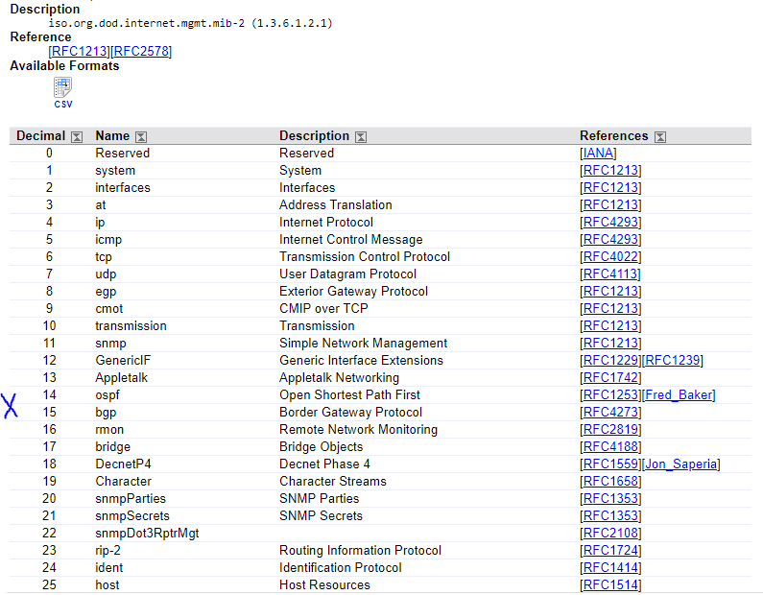](https://akb.arubanetworks.com/media/ckuploads/1110/2021/09/25/ospf-child-oid.PNG)

Polling for OSPF specific OIDs, in this case OSPF Router ID (1.3.6.1.2.1.14.1.1) did not work.

But polling for System Description(1.3.6.1.2.1.1.1) worked.

[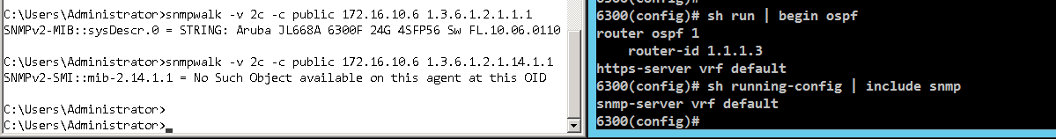](https://akb.arubanetworks.com/media/ckuploads/1110/2021/09/25/no-response-when-polled-for-ospf-router-id_Gf3vBq2.PNG)

**Solution:**

As of now(AOS-CX version 10.08.1010) , this is as per design.

Use command ***snmpv3 context***to make this work.

[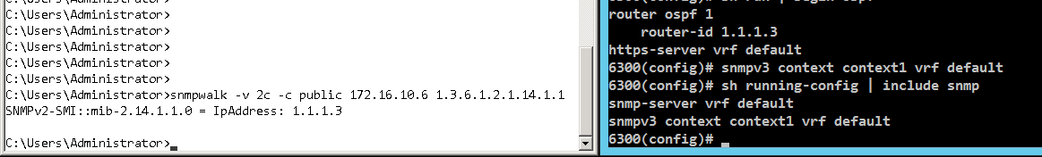](https://akb.arubanetworks.com/media/ckuploads/1110/2021/09/25/snmpv3-context-command-used.PNG)

Note:

1. Use of *snmpv3 context* command is irrespective of snmpv2/v3 setting.

2. The vrf used in the *context* command should match with ospf process' vrf.  
Below, default vrf is used in both *context* command and in the *router ospf 1* command.

6300# sh run | include snmp  
snmp-server vrf default  
snmp-server community public  
snmpv3 context context1 vrf default         << vrf default specified in snmpv3 context  
6300#  
6300# sh run | include ospf   
router ospf 1                                               <<using default vrf  
6300#

3. Context is not required to be specified in NMS while polling. This holds true when vrf is default.

While using a non-default VRF, do specify context in NMS.

[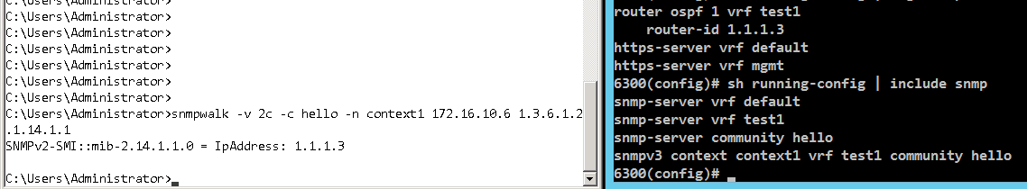](https://akb.arubanetworks.com/media/ckuploads/1110/2021/09/25/using-context-in-nms_3K1z1ha.PNG)

**Configuration:**

[system-view]snmpv3 context [ ] vrf [ ] community [ ]

**Verification:**

While using a non-default VRF, do specify context in NMS.

[](https://akb.arubanetworks.com/media/ckuploads/1110/2021/09/25/using-context-in-nms_3K1z1ha.PNG)

Tags: ArubaOS-CX Switches, arubaos-cx 10.08.xxxx, #aos-cx, #snmpv2, snmpv3, mib-2